CENWP-OD-B 05 July 2022

MEMORANDUM FOR THE RECORD

SUBJECT: 22BON028 MFR WA-AWS LPS RB2 PL Mort

On the morning of 05 July, Bonneville Fisheries discovered one adult Pacific Lamprey mortality in Rest Box 2 (RB2) of the Washington Shore Auxiliary Water Supply Lamprey Passage Structure (WA-AWS LPS). The fish was scanned for PIT tags, inspected, and returned to the river.

- Species – Pacific Lamprey (Entosphenus tridentatus)
- Origin – Unknown
- Length – Approximately 74 cm
- Marks and tags – None
- Marks and Injuries found on carcass – None
- Cause and Time of Death – Unknown.
- Future and Preventative Measures – None

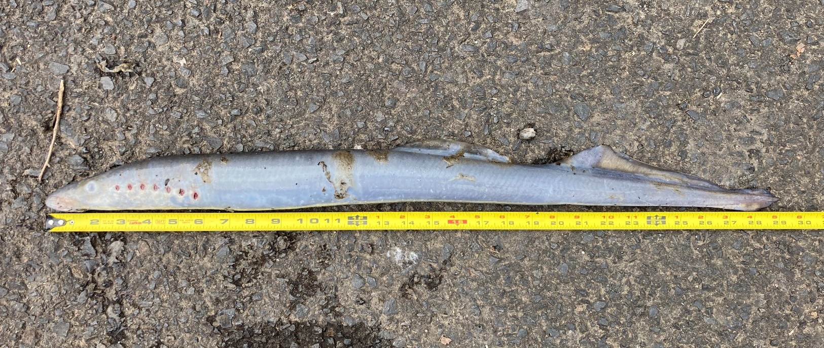
Sincerely,
Bonneville Project Fisheries

